Public Gathering
LEVERETT
COMMUNITY RESILIENCE
BUILDING WORKSHOP

Trees and Ecological Resilience
in Deerfield

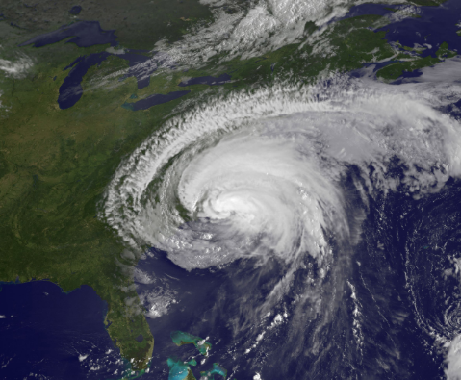 |  |  | 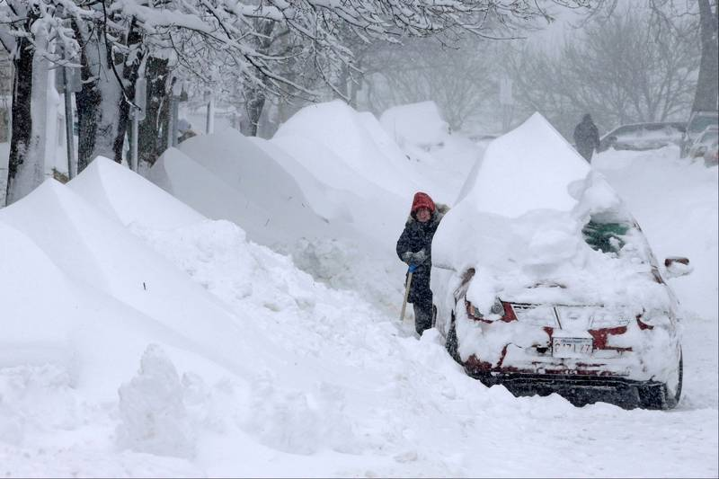
The Town of Leverett and the Franklin Regional Council of Governments invite Town officials and community stakeholders to join this workshop to discuss:
- Connections between natural hazards, climate change, and local and regional planning/mitigation efforts;
- Strengths and vulnerabilities of residents, infrastructure, and natural resources;
- Specific actions that can reduce the impact of hazards and increase our town’s resilience to climate change.

We need to hear your Ideas!

Wednesday, October 23, 9:00 a.m. to 2:00 p.m.
Leverett Town Hall, 9 Montague Road
Refreshments & Lunch will be served
RSVP to Margie McGinnis,
(413) 548-9699 or townadministrator@leverett.ma.us

