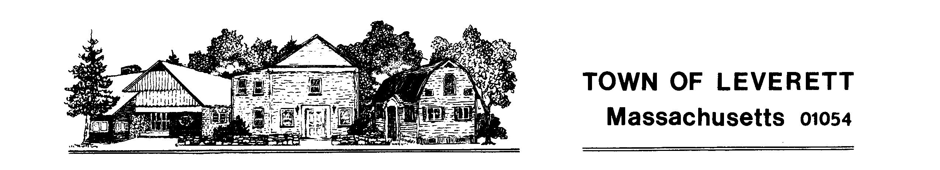

Town of Leverett
Americans with Disabilities Act (ADA)
Self-Evaluation and Transition Plan

Public Hearing
June 12, 2018 at 7:30 pm
Leverett Town Hall
Upstairs Meeting Room

Consultant will present an overview of draft findings and recommendations related to the town’s ongoing efforts to complete an ADA Self-Evaluation and Transition Plan followed by an opportunity for public comment

Public input welcome and encouraged

