It’s MUD SEASON!
Tell us about the condition of your dirt/gravel road!

The Franklin Regional Council of Governments (FRCOG) has partnered with Rep. Natalie Blais to better understand the conditions of our communities’ unpaved roads, and the effort and cost that goes into their maintenance and repair every year. This is especially important in the context of more frequent, intense storms like this past summer that damage these more vulnerable roads.

To help with this effort, the FRCOG has created an interactive online map in which anyone can add points to show the location of known issue spots on your unpaved roads: https://tinyurl.com/3ydvt2d6, or scan the QR code below with your smartphone.

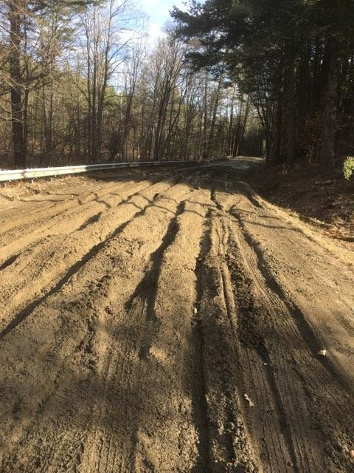
Mark the map with locations that have reoccurring maintenance issues or that are in need of repair.

You can also upload pictures and add details.

Your input will help Rep. Blais make her case in Boston about the needed funding for Western Mass unpaved roads.
Use your smartphone camera and view this QR code to automatically open the interactive map!

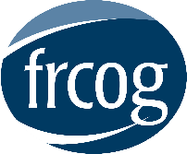
For more information on this project, or to discuss other issues related to dirt/gravel roads, please contact Megan Rhodes, Senior Transportation & Land Use Planner at mrhodes@frcog.org or (413)774-3167 ext. 132.

