NEWSLETTER

TOWN OF LEVERETT www.leverett.ma.us December 2020

Notes From Around Town
• Hunting Season: It is deer-hunting season until Dec. 31, 2020. To keep yourself and your pets safe please wear blaze orange. (As ugly as it is.)
• Please, keep your mailbox clear of snow. The post office will not deliver your packages if the driver can’t easily reach the box.
• Village Neighbors is available for some services to folks over 60, including small home repairs with a grant they received for the labor. Contact Village neighbors.org or call 413-345-6894.

• Leverett has a parking ban: no parking anywhere on the road or roadsides—anytime during a snow storm.

NEXT NEWSLETTER DEADLINES:

1 February, 1 April, 1 June 2021

Send news items and fresh flowers and a vaccine to: Lisa Stratford, Box 300, Leverett, MA, 01054 or e-mail to townclerk@leverett.ma.us. Call 548-9150 for information and guidelines.

The Special Town Meeting and Election have been cancelled due to an order from the Board of Health regarding safety issues due to COVID and large gatherings. The order can be read at www.leverett.ma.us

Winter Reminders:
Winter sand is available to all residents, for private use only, at the Safety Complex. If you are elderly or physically unable to get sand, the Highway Department will deliver a 5-gallon bucket to you. Call 548-9400 for a delivery.
The Select Board has adopted the following policies and would appreciate your cooperation in regard to them:
(February 12, 1996)
No person other than an employee of the Highway Department shall push, pile, plow, or blow snow or ice onto a town or county road that impedes the flow of traffic. Whoever violates this resolution shall be punished by a fine of not more than $50 per offense and be rolled into a snowball with only head and feet sticking out.
(December 29, 2003)
Residents are advised to secure their mailboxes against possible damage from snow removal operations. The Town is not responsible for damage to mailboxes caused by snow removal operations.

From the Select Board
Peter d’Errico, 13-year veteran of the Select Board and recently stepped down as Board Chairman, has stepped down from the Board. At the end of our second outdoor town meeting during the Covid-19 pandemic on October 24, Peter announced his resignation, saying Leverett municipal activities have been invaded by national political events, making it no longer possible for him to continue.
Due to the Covid-19 pandemic the October 24 Special Town Meeting was held in the parking lot of the Elementary School. All eleven articles on the warrant passed. Included among the articles were the purchase of a replacement snowplow for $8,800, the purchase of three new ice rescue suits totaling $2,300, the purchase of a new HVAC unit for the Fire Department for $7,225 and four addressing Community Preservation Act funds administration and allocation.
Margie McGinnis, Town Administrator, and Jim Field, Emergency Planning Board Chair, continue to collect requests from town departments for Covid-19-related CARES Act funds and to reconcile requests for CARES Act funds from the school. As of mid-November, CARES Act 2 town spending totaled $128,000, with about $10,000 remaining.
The Annual Tax Classification Hearing was held during the November 10 Select Board meeting. Jeff Reynolds from the Board of Assessors described the procedure used in establishing the annual tax rate. The Assessors have increased residential assessed values by 2%. The tax levy is yet to be determined. The Select Board voted to set the Residential Factor at 1.0 and corresponding CIP shift of 1.0, meaning residents owning real estate and certain equipment will be taxed on that property at a rate according to 100% of the assessed value of that property. The CIP shift is the adjustment, up or down, that industry or commercial property owners would pay relative to the assessed value. Considering the very minor commercial presence in Leverett, no adjustment above or below 100% will be made to the commercial tax rate.
The Finance Committee has recommended the Board communicate to town departments to budget for not more than a 1.5% increase next fiscal year, and that increase is not guaranteed. The Board accepted the Finance Committee’s recommendation.
The Town hired two police officers, one full-time and one part-time, at the recommendation of Chief Minckler and the hiring committee and following a Select Board interview with the full-time candidate. Steven Gould, the full-time hire, was interviewed by the Select Board from his home in California. Steven will be joining the department as soon as he can move to the area. The hiring committee also gave full support to Angelina Rodriguez for the part-time position and she will begin following proof of a recent physical. Please introduce yourself to Steven and Angelina when you see them as I know they will be wanting to get to know the community.
Police Chief Minckler also announced the department had been awarded two grants for equipment and highway safety totaling close to $47,000.
Highway Superintendent Matt Boucher was pleased to inform the Board that two of Leverett’s fire fighters have applied to be part-time snowplow operators, to operate the smaller vehicles as they do not, as yet, have their commercial driver’s license. Matt also informed the Board that Will Stratford has offered to plow for the town on an as-needed basis. The Board enthusiastically agreed to appoint Nole Bidwell, Brendan Kelly and Will Stratford as temporary employees for winter maintenance.
Matt also reported on the current circumstances with the Mill Yard Road Bridge which has been closed for almost two years now. The Board asked if he could assess the condition of the bridge and provide an estimate if he felt his department could do the repairs. In brief, the state closed the bridge, and he estimates it would take an engineer to investigate the repair at a cost to the town of approximately $50,000. Actual repairs do not appear to be difficult. Considering the next closest bridge is one mile away, Matt feels this bridge currently is not a priority, an opinion the Board shares.
The Board voted unanimously to approve the Idle Free Campaign brought forward by Peggy Wolff from the Energy Committee and Nancy Grossman, town resident. The campaign is designed to reduce energy consumption, reduce toxic substances in the air we breathe and reduce the creation of greenhouse gases. A similar policy was adopted for town-owned vehicles in 2011 and this new policy is meant to extend to all vehicles, private and commercial, while parked in town. Emergency vehicles are excluded from the restrictions. Signs addressing idling were acquired from the MA Department of Environmental Protection following signing of the 2011 policy but were never posted. Peggy will ask the Highway Department to post the signs at the Elementary School, Transfer Station and Post Office/Town Hall. The Energy Committee also will prepare a final draft policy for the Select Board to sign.
Following a town-wide effort led by FRCOG and the Emergency Planning Board, the 2020 Hazard Mitigation Plan for Leverett was finalized, submitted, and unanimously adopted by the Select Board.
And finally, the Leverett Library Trustees have informed the town of two exciting updates: 1) They intend to use a portion of a gift to the library to install ground-mounted solar panels to augment energy supply to the building, and, 2) they have accepted a gift of a 5-foot by 7-foot mural painting to be installed on the roadside outer wall of the building. We will learn more as plans develop with both projects.
Tom Hankinson, for the Select Board

________________________________
Voting During a Pandemic
The challenges for all of us this year are incalculable. Running elections during a divisive campaign and a global pandemic were equally challenging. Thanks to the state legislature several options made voting safe for residents of Massachusetts. Vote-by-mail was very popular in Leverett with 879 voters choosing to vote by mail; 450 voted in person on Election Day; leaving 61 who chose to vote early in person at the Town Hall. Thank you for doing your part to ensure everyone in town stayed safe by wearing masks.
The following people made voting possible by working at the elections, helping to fulfill mail-in ballot requests, or helping to tally votes on Election Night. I am enormously grateful for their willingness to help. Please thank them when you see them.
Sue Swartz John Swartz
Eva Gibavic Barbara Tiner
Judy Raphael Susan Mareneck
Nancy Emond Brian Emond
Dana Tarr Steve Freedman
Tom Masterton Hanna Shea
Terry Tarr Rocky Adriance
Richard Nathhorst Hollie Kalkstein
Robert Weitzman Phil Carter
Sarah Todd Sharon Raskevitz
Diana Balmonte Stacey Lennard
Noah Saxenian Steve Saxenian
Mary Hankinson Brian Blinn
Linda Hillenbrand Mara Waskiewicz
Mark Gamble Shannon Gamble
Chris Condit Laurie Brown
Calla Crafts Aaron Buford
Tom Ewing Bill Irvine
Sue Leschine Leah Larkey
Caleb Seamon
Leverett’s election results are available on the town website: www.leverett.ma.us
Lisa Stratford, Town Clerk
Leverett’s Season of Giving

The Kimball Trust was set up in 1909 in the will of Catherine Kimball to provide clothing for Leverett children in need. You may make checks payable to Kimball Trust, in any amount, and send to Collector, PO Box 300.

The Select Board will be collecting food at the Town Hall, School, and Library to bring to the Montague Food Pantry. No doubt your generosity will be greatly appreciated.

When your tax bill comes your voluntary donation will assist many of our elderly and disabled residents to ease their real estate tax bill. If every household donated $5 we would have close to $4,000 to defray the burden for our qualified residents. Look for the check-off box on your bill.
Thank you.

December greetings from the Library!
As we head into winter, Leverett Library continues to provide for our community during the pandemic. The library is currently open for limited browsing appointments. You can book your 30-minute appointment by emailing or calling the library, or by using our appointment app on our website. Curbside service continues. Remember, if you are stuck on what to read next, Sue and I are happy to put a bag of books together for you to try. There are many other items that can be picked up via curbside: printed documents, crossword puzzles, jigsaw puzzles, and kits. Our curbside hours are Tuesday and Thursday 3:00-6:00, Wednesday 10:00-12:00, and Saturday 10:00-1:00.
The Library will try to keep you busy, connected, and entertained during the long winter months! Several monthly programs will continue through the winter. Take- and-Make Craft Kits for adults and kids, online Ukulele Strum-Alongs, Story Walks along the trail, and a Mystery Book Club all happen monthly. Online Qigong on Monday and Wednesday mornings continues as well. In December, a monthly Take-Away Bingo for all ages starts! You can get a “bingo” by completing prompts that ask you to read more and to get outside. On December 6th, the library hosts an online fire cider workshop, and in the coming months, there will be a children’s author panel discussion, a decluttering workshop, and more. Details for all these coming events can be found on our website www.leverettlibrary.org and our Facebook page.
A big thank you to the Friends of Leverett Library for making these programs possible. Be sure to check out their Annual Holiday Basket Raffle! You have until December 12th to submit your bid.
Remember that Sue and I are here for you! Always feel free to reach out with questions. We are happy to help. You can reach us at leverett@cwmars.org or 413-548-9220. We wish you all a happy and safe holiday season.
-Misha Storm, Leverett Library Director

Holiday Recycling Guidelines
During the holiday season, the average American family increases household trash volume by over 25% (US EPA). A large portion of this trash could be avoided, reused, recycled, or composted. Reducing holiday waste can help your household save money on “Pay As You Throw” town trash stickers or bags, save money for your town, and reduce your carbon footprint.
Yes, please DO RECYCLE these:
- gift wrap, tissue paper (no foil, metallic inks, or glitter.) Tape is OK.
- paper gift bags and shopping bags
- greeting cards (except those with foil, glitter, or batteries)
- envelopes (plastic windows are OK)
- catalogs, calendars
- cardboard: corrugated, paperboard
No, please DO NOT recycle:
- ribbons, bows, tinsel (reuse or trash)
- holiday light strings (acceptable in scrap metal recycling)
- Christmas tree netting
- bubble wrap, packing peanuts, polystyrene (Styrofoam) (clean packing materials accepted for reuse at Greenfield UPS Store)
- plastic bags (clean, dry plastic bags marked #2 or #4 accepted in retail store programs)
- plastic “blister pack” packaging (i.e. from toys and electronics)
- photographs (traditional, glossy type)
To learn more about recycling in our region, please visit springfieldmrf.org. (For a downloadable guide to Recycling on the Holidays, click on “What’s Recyclable?”)
Another way to reduce holiday trash is by composting food and paper waste generated by holiday meals. The municipal compost programs at the transfer stations in Bernardston, Conway, Deerfield, Greenfield (open to non-residents), Leverett, New Salem, Northfield, Orange, Wendell, and Whately accept all types of food waste (no liquids), including meat, bones, cheese, plus paper waste such as paper napkins, paper towels, and more. Free; permits may be required.
The Solid Waste District sells discounted “Earth Machine” home compost bins and compost pails to District residents. It is not recommended to put meat, bones, dairy in home compost bins. For more details and pricing (varies by town), contact us or see: www.franklincountywastedistrict.org/compostbinsales.html

Lisa, Margie, Tom, and Julie wish to thank Peter for his relentless hard work on behalf of the Town of Leverett, and for his friendship and camaraderie over the years. He has been, and will be, greatly missed.
Board of Health
The Mass DEP (Dept of Environmental Protection) is launching a free program to test well water from towns where there is a predominance of private wells, such as Leverett. They are testing specifically for PFA’s, polyfluoroalkyl substances, which are chemicals that have been used in a variety of consumer products for the past 50 years.
The wells that will be selected for testing are those that the DEP has deemed worthy based on geographic distribution within the town and/or proximity to potential sources of PFAS. MassDEP/the UMass contactor/local partners will contact the identified well owners and offer the opportunity to sign up for free PFAS sampling. A total of up to 40 wells will be selected. So, just a heads up that you might be contacted to get involved in this free project. You may wish to sample your well even without knowledge of specific potential sources of PFAS contamination, because many potential sources of PFAS have yet to be identified.
Leverett BOH

Leverett Energy Committee
One day last Spring, I had reason to park briefly on the side of Montague Road in front of the Leverett Elementary School. There were about 7 other cars lined up. I was there to pick up a sick child and was expecting said child to appear in the school front doorway with his one-on-one person who routinely accompanies him from school to waiting car. It was April, not very warm, but not cold either. I turned off the car and got out the current New Yorker to read while I was waiting. Before a moment passed, I was breathing exhaust from the empty car left idling in front of me. This was no fun; certainly not how I wanted to spend an unexpected moment of free time in my car. I rolled down the window and pretty quickly noticed a lot of exhaust smoke hovering over all the parked cars. I got out of the car to investigate and discovered that just one car besides mine was turned off; the others were all sending out exhaust; one of the idling cars was occupied. Not an uncommon experience, right? Not pleasant, either. So, as I often say to myself in annoying situations that maybe do not need to be happening: NOW WHAT?
It's long been known that breathing exhaust is unhealthy for everyone. There has been some good action to protect children from exhaust emitted by long-standing school buses. But what about the rest of us most of the time? Is there a way for us to reduce/eliminate idling in town without anyone getting hypothermia or being indignantly harassed? Time to establish and enforce an official, sensible, and visible PLEASE DO NOT IDLE policy?
The energy committee has supported related efforts to publicize the idling issue e.g. the hand-outs at last year's Town Meeting. Several months ago, led by member Peggy Wolff, the committee began meeting with the Select Board to establish just such a specific-to-Leverett policy with suggested ways to educate ourselves, publicize the issue, and arrange for reasonable strategies to implement the new policy. There is some flexibility in the regulations, by the way...for example, there are no plans for a band of "exhaust police" to pounce on us, although in some instances of chronic non-compliance we can have both discretion and power-to-enforce. The whole point is how we best serve the Common Good in matters of public health and safety. We are talking about our air quality, personal health, and--from the larger perspective--the health of the earth's atmosphere that we all need to live well. Peggy has consulted with the Massachusetts Department of Environmental Protection (DEP) and used its updated material for our policy. The DEP is pleased to give us copies of its newest materials which include a No Idling Toolkit and NO Idling pledge forms for individuals and families. At in-person and remote meetings, Peggy and town resident Nancy Grossman have brought this issue to the Board and on Tuesday, November 24, the Board granted approval for us to formally continue. Some details we can share with you here include information brought to us about areas in town where excessive idling has been noted. These include the Town Hall/Post Office area; several sites around the elementary school; the Transfer Station; the Co-op and possibly other
areas. The committee will keep everyone informed as we continue our work and will be seeking input from residents.
Portia Weiskel for the Leverett Energy Committee
pweiskel@post.harvard.edu
548-9737
Shirley and Brooke Thomas; George Lockwood; Cynthia Thomas; Peggy Wolff; Richard Nathhorst

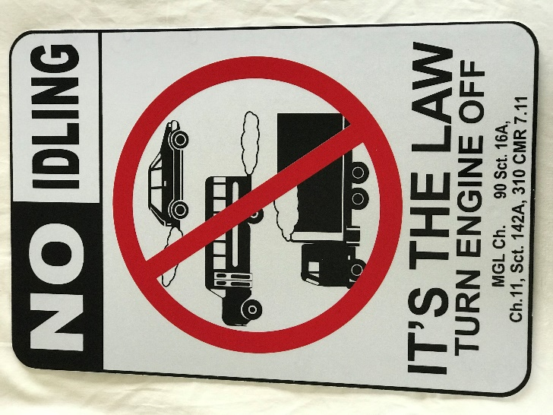

Village Neighbors is available for some services to folks over 60, including small home repairs with a grant they received for the labor. Contact Village neighbors.org or call 413-345-6894.

There will be a 250th Anniversary Zoom meeting open to the whole town on Sunday, January 10 at 3 PM. We will be forming committees to work on each activity, so anyone who wants to help is encouraged to attend. People should email Leverett250@yahoo.com if they want attend: the Zoom link will be sent out early January.

The Leverett Historical Society Is Coming Back to Life!
It has been several years since The Leverett Historical Society (LHS) has been active. Recently our only public activity has been our annual plant sale, which was a victim of COVID this year! This loss of our annual fundraiser was unfortunate because its income helped us pay our building insurance each year as well as basic utility costs.
In case you have forgotten, or never knew, LHS cares for two very special historical buildings in town; one is in the center of town, The Leverett Museum (aka The Field Family Museum or The Old Library) and the other is The Moore’s Corner Schoolhouse (diagonally across from the Village Co-op). Both locations have collections of donated local artifacts, photographs, books and papers, and genealogy materials depicting the agricultural, economic, and industrial endeavors of the town as well as its social history.
To get things started again there has been cleaning and sorting at the MC Schoolhouse as well as continuing efforts on existing projects at The Leverett Museum. We are also working with the Leverett Historical Commission to compose a CPA grant proposal to obtain funds for assistance with organizing our inventory and to archive the paper collections for preservation purposes as well as create digital availability of the archives to everyone.
We are planning to eventually revive and renew our membership base again; however, for now, we will accept monetary donations towards helping LHS to continue with its historical endeavors. LHS is a non-profit organization; therefore, donations are tax deductible. Checks can be mailed to: LHS P.O. Box 57 Leverett, MA 01054.
Also, if you are affiliated with UMass, even as a retiree, the UMASS Community Campaign (UMACC) (www.umass.edu/umacc/ ) is another way of contributing to LHS.
Once we get things cleaned up and organized and when it is COVID safe again, we’ll be ready to present public programs and look forward to being part of Leverett’s 250th celebration!
For further LHS info or to become involved, e-mail: LeverettHistoricSoc@gmail.com
Thank you, Edie Field and Dawn Ward

Tax Relief Committee
It’s that time of year again, and The Tax Relief Committee wants to remind Leverett homeowners/taxpayers, of two important facts:
- When you pay your property tax bill, consider making a modest donation to the tax relief fund: you can check the box conveniently provided on your bill. Even a modest amount, say of $5 per homeowner, makes a difference. Thanks to the generosity of Leverett Taxpayers, financial assistance was provided to ten applicants who requested help with paying their tax bills in the spring of 2020. Awards were smaller than in previous years, as we had less $ to work with, and ranged from $300-$600. We are asking for your help once again, in order to replenish the tax relief fund, which has been largely depleted. This fund relies almost entirely on your donations. We hope to be able to continue to provide this financial support to your elderly and disabled neighbors during this difficult time. Which we can’t do without you.
- If you are a senior citizen or have a disability and find it challenging to afford your property tax bills, you may contact the Assessors’ office to request an application for tax relief. The Tax Relief Committee reviews applications once a year, in the spring, and makes awards (based on how much is in the tax relief fund) prior to when the second tax bills are due.
Checks made out to the "Tax Relief Fund, Town of Leverett", can also be sent directly to the Tax Collectors Office, PO Box 300, Leverett, MA 01054 at any time.
Tax Relief Committee

Leverett Social Justice Committee
The Leverett Social Justice Committee was formed by the Select Board this summer with the goal of identifying systemic barriers to social justice and making recommendations to address those barriers. We are a diverse and committed group of townspeople, and we define social justice as the act of examining and changing policies, structures, and institutions to eliminate systemic inequalities. We continue to meet weekly to discuss progress on our many ongoing projects, but much of our work right now is happening at the subcommittee level:

- The Policing Subcommittee has started to build connections with the Wendell community, given that the LPD will be overseeing their policing for the foreseeable future. Closer to home, Aaron Buford represented us on the new officer hiring committee, and we look forward to continuing to contribute to conversations about the values we want our public safety officials to hold! We have also been discussing two initiatives with Chief Minckler that we hope will bear fruit soon: first, a forum where the LPD can hear from Leverett residents of color about their personal experiences with policing over their lives, and second, developing a public data-reporting system that will allow town residents to more easily learn about the LPD and policing in our town. We look forward to continuing to collaborate with Chief Minkler and the other Leverett Police officers on these projects.
- The Town Government subcommittee has been looking into ways of increasing townspeople’s participation in government and Town Meeting, particularly given the COVID-19 pandemic. The SJC is interested in how new technologies might offer opportunities to improve access to voting and participation. We are eager to talk to residents about their experiences with accessibility and if there are ways, the process could improve. To this end, we have created a survey to assess townspeople experiences with town government. The survey is anonymous, and can be filled out electronically at bit.ly/leverettsurvey. If pen-and-paper is more your style, there are blank copies and drop-off boxes/envelopes at Town Hall, the front door of the LES, or the Library (use the book drop slot).
- The Schools subcommittee has been working closely with interim Principal Annie Foley-Ruiz. These meetings have explored options for professional development and consultation for the school in its effort of combatting racism at all levels. Additionally, LSJC member Grace Johnson, who is a current ARHS student, has started researching what former LES students have to say about the school’s teaching of social justice and how it prepared them to enter ARMS and ARHS. She is creating a survey to distribute to former Leverett Elementary School students. We are very excited to continue to collaborate with Annie and the rest of the LES teachers and staff.
Abriete Medore, on behalf of the LSJC

FRIENDS OF THE LEVERETT LIBRARY

Our annual membership drive is underway. We hope to schedule the annual meeting in the spring of 2021. On the back of the Newsletter is a form to share with neighbors and friends to help support our library which has been working behind the scenes during 2020 to provide on-line resources for our community.
______________________
“Stonewall Lift” is rocking! Many ‘attended’ a Zoom with Eva Gibavic last November 1st on how to photograph your stonewall and send your shots to leverett.mapping@gmail.com so we can have a mapping of the stonewalls in Leverett. If you missed it or want a refresher, the Zoom recording can be found on the Leverett website. If you have a stonewall along the roadside particularly, consider giving it a ‘lift’ to enhance our town’s beauty and proudly show off some of our heritage. Dress it up for the Holiday Season if you are so inclined! Consider it a great activity to get family, friends, and neighbors outside and have some fun while enhancing our town and preparing it for our 250th Celebration. Please let Eva or Sara Robinson (sarar@umass.edu) in on the progress you are making or if you want to teamwork to help others!

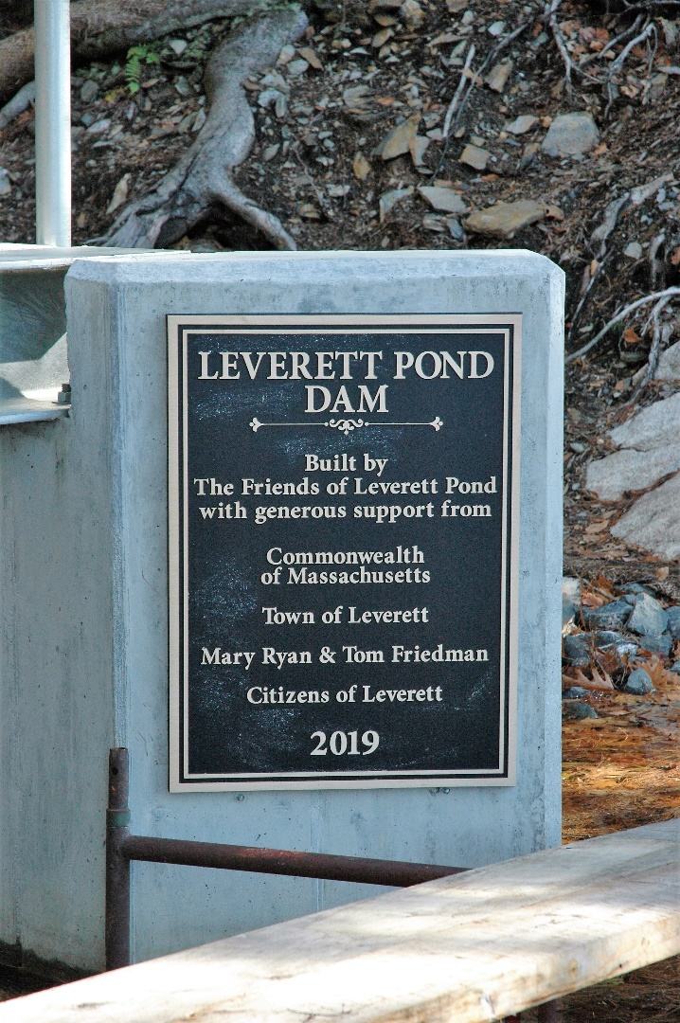

Thank you, Leverett!

This space left blank intentionally. Write all the things you will do once the pandemic is over here:

PRSRT STD
US POSTAGE PAID
AMHERST, MA 01002
PERMIT NO. 20

LEVERETT RESIDENT

LEVERETT, MA 01054

_________________________________________________________________________________
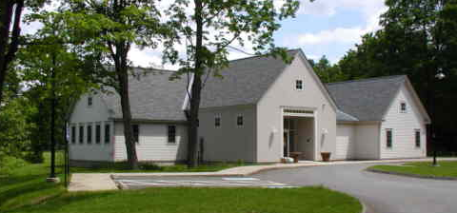
Friends of Leverett Library
P.O. Box 250 Leverett, MA 01054-0250
Friendsofleverettlibrary@gmail.com
It is not too soon to renew your membership for the 2021 calendar year. Please use the form below to make your annual contribution.
MEMBERSHIP APPLICATION/MEMBERSHIP RENEWAL FOR THE CALENDAR YEAR 2019
Please complete and send to the library at: Box 250, Leverett, MA 01054
Circle membership type: Individual $10 Family $20 Patron $50 Lifetime $200
If your membership is other than “individual” please tell us how many people should be listed in our statistics for your membership (e.g. family of 4):__________________

NAME_______________________________________________TELEPHONE________________

ADDRESS______________________________________________________________________

EMAIL ADDRESS______________________________________________________________________
We ask for your email address so that we can send an acknowledgement of your membership and very occasionally send you information about events and our annual meeting. We are not allowed to access your email address from library patron records and we will not share your email address with anyone. ALL DUES AND DONATIONS ARE TAX DEDUCTIBLE

The Newsletter is affectionately published by the Town of Leverett 6 times per year and mailed to each address in Leverett (about 850) and subscribed to worldwide. It is the official publication of the Town and accepts articles from Town boards and committees. No politicizing or editorializing is allowed. When space is available, items from nonprofit organizations may be included. No advertising for the sale of goods or services for personal gain is allowed.
Cover art by Margaret Nutting.
Edited and humorously written by Lisa Stratford and town-friendly proof-read by Portia Weiskel.

